**Assignment -1**

Python Programming

|  |  |
| --- | --- |
| Assignment Date | 07 October 2022 |
| Student Name | Yashika U |
| Student Roll Number | 511919104026 |
| Maximum Marks | 2 Marks |

**Dataset**

**Question-1:**

1. Importing the dataset

**Solution-1:**

from google.colab import drive

drive.mount ('/content/drive')

**Output:**

Mounted at /content/drive

**Solution-2:**

cd/content/drive/MyDrive/

**Output:**

/content/drive/MyDrive

**Solution-3:**

! unzip Flowers-Dataset.zip

**Output:**

Output exceeds the [size limit](command:workbench.action.openSettings?%5B%22notebook.output.textLineLimit%22%5D). Open the full output data [in a text editor](command:workbench.action.openLargeOutput?2e49110e-47af-49cd-adbc-06d6ef0f1ad3)

Archive: Flowers-Dataset.zip inflating: flowers/daisy/100080576_f52e8ee070_n.jpg inflating: flowers/daisy/10140303196_b88d3d6cec.jpg inflating: flowers/daisy/10172379554_b296050f82_n.jpg inflating: flowers/daisy/10172567486_2748826a8b.jpg inflating: flowers/daisy/10172636503_21bededa75_n.jpg inflating: flowers/daisy/102841525_bd6628ae3c.jpg inflating: flowers/daisy/10300722094_28fa978807_n.jpg inflating: flowers/daisy/1031799732_e7f4008c03.jpg inflating: flowers/daisy/10391248763_1d16681106_n.jpg inflating: flowers/daisy/10437754174_22ec990b77_m.jpg inflating: flowers/daisy/10437770546_8bb6f7bdd3_m.jpg inflating: flowers/daisy/10437929963_bc13eebe0c.jpg inflating: flowers/daisy/10466290366_cc72e33532.jpg inflating: flowers/daisy/10466558316_a7198b87e2.jpg inflating: flowers/daisy/10555749515_13a12a026e.jpg inflating: flowers/daisy/10555815624_dc211569b0.jpg inflating: flowers/daisy/10555826524_423eb8bf71_n.jpg inflating: flowers/daisy/10559679065_50d2b16f6d.jpg inflating: flowers/daisy/105806915_a9c13e2106_n.jpg

inflating: flowers/daisy/10712722853_5632165b04.jpg inflating: flowers/daisy/107592979_aaa9cdfe78_m.jpg inflating: flowers/daisy/10770585085_4742b9dac3_n.jpg inflating: flowers/daisy/10841136265_af473efc60.jpg inflating: flowers/daisy/10993710036_2033222c91.jpg

...

inflating: flowers/tulip/9870557734_88eb3b9e3b_n.jpg inflating: flowers/tulip/9947374414_fdf1d0861c_n.jpg inflating: flowers/tulip/9947385346_3a8cacea02_n.jpg inflating: flowers/tulip/9976515506_d496c5e72c.jpg

**Question-2:**

2. Image Augmentation

**Solution-1:**

from tensorflow.keras.preprocessing.image import ImageDataGenerator

train_datagen = ImageDataGenerator(rescale=1./255,zoom_range =0.2,horizontal_flip=True,vertical_flip = False)

test_datagen = ImageDataGenerator ( rescale = 1. / 255 )

x_train =train_datagen.flow_from_directory(r"/content/drive/MyDrive/flowers",target_size =(64,64),class_mode ='categorical',batch_size=24)

**Output:**

Found 4317 images belonging to 5 classes.

**Solution-2:**

x_train.class_indices

**Output:**

{'daisy': 0, 'dandelion': 1, 'rose': 2, 'sunflower': 3, 'tulip': 4}

**Solution-3:**

xtest = test_datagen.flow_from_directory('/content/drive/MyDrive/flowers',

target_size=(64,64),

class_mode='categorical',

batch_size=100)

**Output:**

Found 4317 images belonging to 5 classes.

**Question-3:**

3. Create model and adding layers

**Solution:**

from tensorflow.keras.models import Sequential

from tensorflow.keras.layers import Convolution2D,MaxPooling2D,Flatten,Dense

model = Sequential() #Initializing sequential model

model.add(Convolution2D(32,(3,3),activation='relu',input_shape=(64,64,3))) #Convolution layer

model.add(MaxPooling2D(pool_size=(2,2))) #MaxPooling layer

model.add(Flatten()) #Flatten layer

model.add(Dense(300,activation='relu')) #Hidden layer 1

model.add(Dense(150,activation='relu')) #Hidden layer 2

model.add(Dense(4,activation='softmax')) #Output layer

**Output:**

Model created successfully

**Question-4:**

4. Compile the model

**Solution:**

model.compile(optimizer='adam',loss='categorical_crossentropy',metrics=['accuracy'])

model.summary()

**Output:**

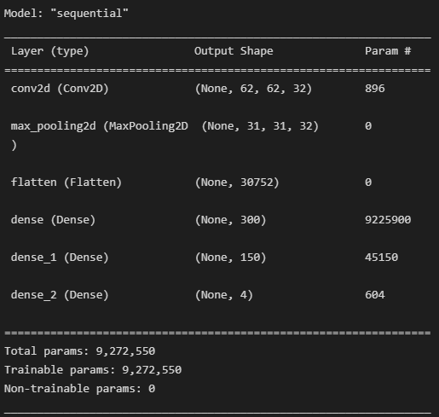

**Question-5:**

5. Fit the model

**Solution:**

from keras.callbacks import EarlyStopping, ReduceLROnPlateau

early_stopping = EarlyStopping(monitor='val_accuracy', patience=5)

reduce_lr = ReduceLROnPlateau(monitor='val_accuracy', patience=5, factor=0.5,min_lr=0.00001)

callback = [reduce_lr,early_stopping]

model.fit(x_train,

steps_per_epoch=len(x_train),

epochs=50,

callbacks=callback,

validation_data=x_train,

validation_steps=len(x_train))

**Output:**

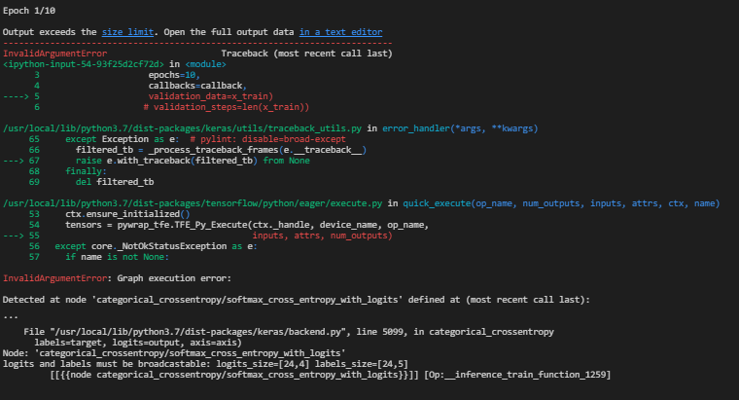

**Question-6:**

6. Save the model

**Solution:**

model.save('flowers.h5')

**Output:**

'Model saved

**Question-7:**

7. Test the model

**Solution-1:**

img=image.load_img('/content/drive/MyDrive/flowers/dandelion/10043234166_e6dd915111_n.jpg',target_size=(64,64))

x=image.img_to_array(img)

x=np.expand_dims(x,axis=0)

pred=np.argmax(model.predict(x))

op=['daisy','dandelion','rose','sunflower','tulip']

op[pred]

**Output:**

‘sunflower'

**Solution-2:**

img=image.load_img('/content/drive/MyDrive/flowers/sunflower/1008566138_6927679c8a.jpg',target_size=(64,64))

x=image.img_to_array(img)

x=np.expand_dims(x,axis=0)

pred=np.argmax(model.predict(x))

op=['daisy','dandelion','rose','sunflower','tulip']

op[pred]

**Output:**

‘sunflower'